# CoreJava Concepts

**Understanding JVM Architecture:**

Java files are compiled and convered into class files called byte code.

Java Runtime Environment composed of the Java API and JVM.

JVM will load java class through one of its class loader and execute it along with Java API.

NOTE: JVM is platform dependent.

Reference: <https://www.youtube.com/watch?v=ZBJ0u9MaKtM>

**JVM Architecture has following areas.**

* Class loader subsystem,
* Runtime data areas
* Execution engine

**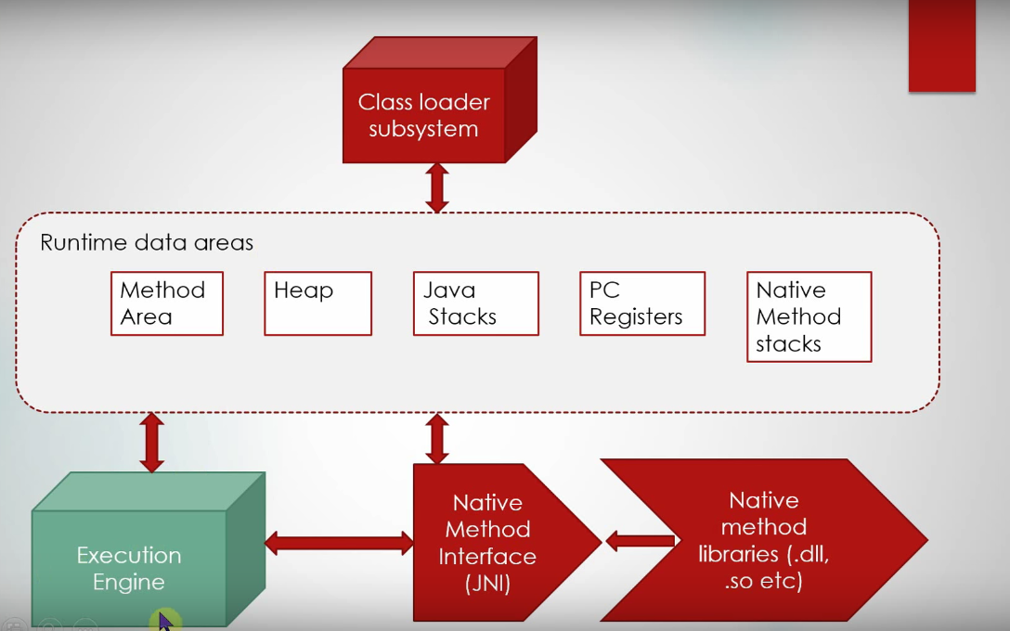**

**Class Loader Subsystem:** Class loader subsystem has three main phases.

* Load
* Link
* Initialize

Load Phase involves three different types of class loaders

1. Bootstrap Class loader (**rt.jar**)
2. Extension Class Loader (**jre/lib/ext**)
3. Application ClassLoader (**Classpath** or **–cp**)

Link Phase has three different phases

* Verify
* Prepare
* Resolve

**Verify**: Magic number verification etc.

**Prepare**: Memory for the class variables happends (static variables). Default values assigned in this phase.

**Resolve**: Symbolic references are resolved. Class references etc. if the class is not found ClassDefNotFound exception is thrown.

**Initialize Phase:** static blocks are initialized. Actual values are assigned in this Phase in the memory location.

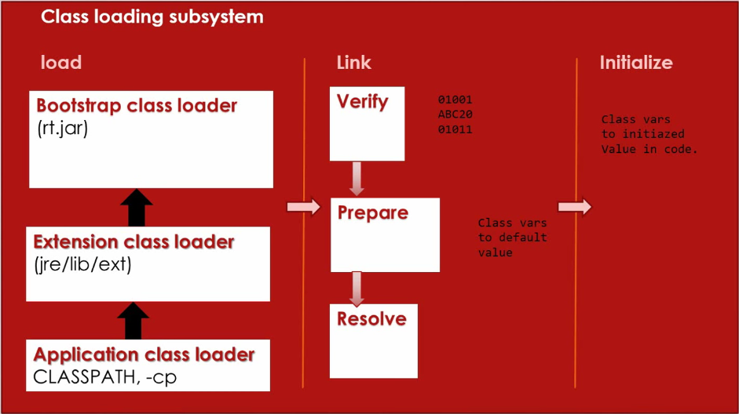

**Runtime Data Areas**

**Method area:** Method area contains class metadata. Byte code etc. it is also called **Permgenspace**. **–XX: MaxPermSpace.**  In java 8 it is called **MetaSpace**. Moved permgen into separate memory in native operatiing system memory. Metaspace doesn’t have limit it can grow in system memory. Using some Parameter you can limit.

**-XX: MetaspaceSize=<size>**

**-XX: MaxMetaspaceSize=<size>**

**Heap:** Heap is an important memory area. Objects, instance variables and arrays are created inside the heap.

Using -**Xms**={¼th Physical memory} and –**Xmx** we can customize Heap memory.

**PC Registers:** Program Counter Register. It is pointer to the next instruction for Thread.

**Java Stack:** Stack Frame is specific to method. Used to store local variables. If the recursive algorithm is infinite **java.lang.StackOverflowError**

**Native Method Stack:** Native method stack.

**Execution Engine: It contains four main areas**

1. **Interpreter:** interprets bytecode into machine level code
2. **JIT compiler:** repeatedly interpreted instructions directly compilter on the fly. The just-in-time compiler comes with the virtual machine and is used optionally. It compiles the bytecode into platform-specific executable code that is immediately executed. Sun Microsystems suggests that it's usually faster to select the JIT compiler option, especially if the method executable is repeatedly reused.
3. **Hotspot profiler: it helps JIT compiler**

The -Xprof profiler is the HotSpot profiler. HotSpot works by running Java code in interpreted mode, while running a profiler in parallel. The HotSpot profiler looks for "hot spots" in the code,

i.e. methods that the JVM spends a significant amount of time running, and then compiles those methods into native generated code.

The embedded HotSpot profiler is a specialist low overhead profiler suitable for running alongside the application while not causing too much of an overhead. It does this by being a very very simple profiler, using the lowest overhead techniques available.

Firstly it samples the runtime stack (the methods currently being run) at regular intervals. In order to make this sampling have minimal impact, the interval between samples being taken is not too short. But much more importantly, unlike most stack sampling profilers, the stack is not "walked", i.e. the elements on the stack are not identified in full. Instead only the topmost element of the runtime stack is identified, i.e. the method in which code is being executed at the sample time.

This sampling of the topmost runtime stack element is sufficient to identify which methods need to be compiled into native code. Basically, **if any method is found to be at the top of the stack more than a few times,** then the application can probably benefit from having that method compiled. Simple, but powerful

1. **GC:** Garbage collection.

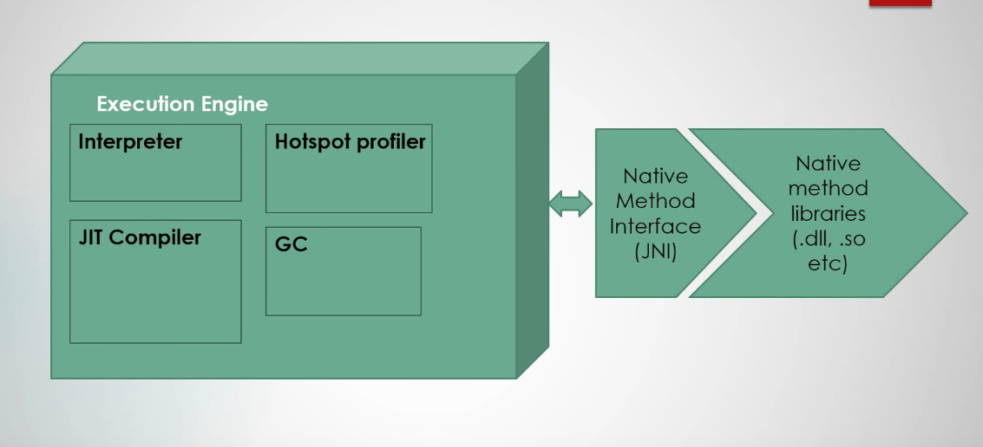

**Java runtime data areas**

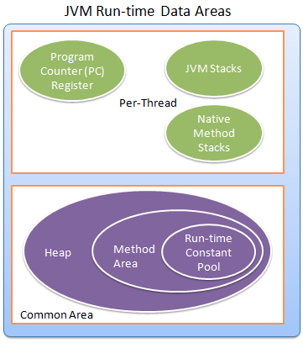

**Runtime data areas are broadly classfied into two groups**

1. **Data areas are specific to thread**. Where are managed by thread. When a Thread started these areas gets created. When thread execution is completed these memory areas also removed.
2. Program Counter Registers
3. JVM Stacks
4. Native Method Stacks
5. **Data areas which are shared by multiple threads**: These areas are created when JVM starts destroed when JVM terminates.
6. Heap Memory
7. Method Area
8. Run-time Constant Pool

**Program Counter Register:** It will keep a pointer (🡪) to the currently executed statement that is being executed by the thread.

If thread is executing native method then PC pointer value is undefined.

**JVM Stacks:** JVM stacks are used to store JVM Frames and JVM will not do any manipulation to the Stacks. Memory size of Stacks is two types fixed size and dynamic size.

**Heap Memory:** Heap memory is used to store Objects and arrays. This memory is shared across all the threads. Garbage collector will works on this memory area.

**Method Area:**  it contains meta-data and class memory information; constructor information is store in this area. Run time constant pool also part of this area.

This is also called permgen space until JDK 1.7. In JDK 1.8 it is removed and called Metaspace that is no longer part of heap.

**Runtime constant Pool:** Until JDK 1.7 it is created inside the Method area (Permgen space). When a class or interface is created. It contains the literals.

We can also called it is as a String Constant Pool.

**Q) ClassNotFoundException**:  ClassNotFoundException occurs when class loader could not find the required class in class path. So, basically you should check your class path and add the class in the classpath.  
  
**NoClassDefFoundError**: This is more difficult to debug and find the reason. This is thrown when at compile time the required classes are present, but at run time the classes are changed or removed or class's static initializes threw exceptions. It means the class which is getting loaded is present in classpath, but one of the classes which are required by this class, are either removed or failed to load by compiler .So you should see the classes which are dependent on this class.

**Q) What all memory areas are allocated by JVM?**  
Heap (method area/ permgen space, runtime consant pool), Stack, Program Counter Register and Native Method Stack

**Q). What are the three steps of GC?**

**Mark:** it Tranvers the entire object grap and mark or unmark each and every node in that graph.

**Sweep:** cleans up the objects that are not reachable.

**Compacting:** rearrange objects (contiguous mean side by side)

<https://www.youtube.com/watch?v=UnaNQgzw4zY>

**Q) What is MaxTenuringThreashold?**

This is value of each object in the young generation Heap memory. It is the number of cycles it is sruvivde before going into old generation.

Young Generation having **Eaden**, **Survivor1** and **Survivor2** spaces. Each minor GC is called on Eaden space and moved objects to S1 or S2 space until this threashold value is reached. After that it moves into Old generation.

**Q) What is latency and throughput?**

* **Latency:** How quickly application responds for the piece of data.
* **Throughput**: number of inputs allows within a unit of time.

**Q) What are different Garbage collectors in java?**

**Serial Garbage Collector:**

**Parallel Garbage Collector:**

**CMS: Concurrent Mark Sweep:**

**G1: Garbage first**

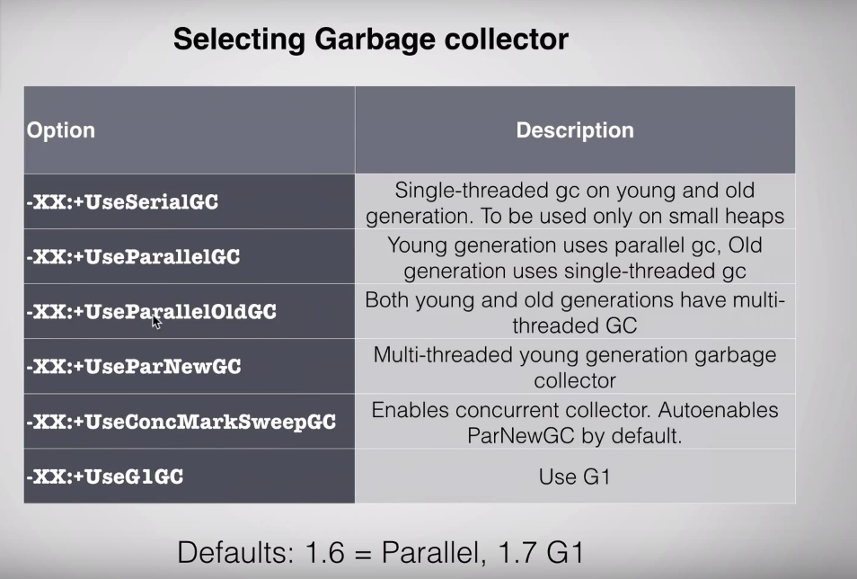

**Q). What is the difference between dynamic Polymorphism vs Static Polymorphism?**

**Dynamic polymorphism** is run time polymorphism that is invokes overrided method using parent class reference.

**Static Polymorphism** is compile time polymorphism, which means invoking overloaded method /static method.

**Q). What is aggregation how it is useful?**

Aggregation is one type of association and it is directional association. Which is Has-A relationship. Example Address entity is aggreation with Student, College, Staff.  **In UML it is represented as open diamond arrow.**

Hecne 🡺 Student **Has-A** Address

🡺 College **Has-A** Address

🡺 Staff **Has-A** Address

**Q). What is Associattion?**

Association establishes relation between two classes through their objects.

Ex: Car.name is using by Driver.name

Here Car and Driver are two classes made a relationship.

**In UML it is represented as Arrow or strait line.**

**Q) What is composition?**

Compostion is resticted form of Aggregation that is strictly dependent on each other.

**In UML it is represented as closed diamond arrow.**

**Q) What is Coupling and Cohesion?**

**Coupling:** By definition coupling is the degree to which one class has knowledge of another or in other words one class has a dependency upon another.

**Cohesion:** Class is designed to specific purpose instead of multiple sets of functions. High Cohesion

**Q) S.O.L.I.D Principles?**

**S- Single Responsibility Principle:** One class should have one and only one responsibility. Class should have only one reason to change.

**O- Open Close Principle:** Software components should be open for extension, but closed for modification

**L-Liskov Substituion Principle:** Derived types must be completely substitutable for their base types

**I- Interface Segregration Principle:** Clients should not be forced to implement unnecessary methods that they will not use

**D-Dependency Inversion Principle:** Depend on abstractions, not on concretions.

**Q) What is the purpose of Volatile keyword?**

In a multi-theading environment it will always check the value of the variable in the main memory instead of CPU cache. So that half initialized values you never get.

**Q) What is Encapsulation?**

Hiding the implementation details from outside by making the fields as private and writing getter and setter methods.

**Q) What are the annotations and what are the built in annotations in core Java?**

Annotations are meta-data for the classes and methods.

There are three built-in annotations in java

(@Deprecated, @Override, @SuppressWarning)

**Q) How to create custom annotations?**

Annotations are created using **@interface.** All annotations extends **java.lang.annotation.Annotation** interface**.**

**@Documented** annotation indicates that element using this annotation should be documented by JavaDoc. When you generate javaDoc it is included in that.

**@Target (ElementType.*METHOD*):** it specified where we could use the annotation. In the below code, we have defined METHOD which means that below annotation can only be used on methods.

**@Inherited:** The @inherited annotation singals that a custom annotation used in a class should be inherited by all of its sub classes.

**@Retention (RetentionPolicy.*RUNTIME)*:** it indicates that how long annotation with the annotated types are to be retained.

**Q) What is the difference between String literal and String Object?**

String literals are stores in the String constant Pool and String objects stored in the Heap.

String s1=”Hello”;

String s2= new String (“Hello”). Intern ();

Now s1==s2 🡺 true

**Q) How does String intern method works?**

**String.intern()** method can be used to to deal with String duplication problem in Java. By carefully using the intern() method you can save a lot of memories consumed by duplicate String instances.

A string is duplicate if it contains the same content as another string but occupied different memory location e.g. str1 != str2 but str1.equals(str2) is true. Since String object consumes a large amount of heap memory in average Java application, it makes sense to use intern() method to reduce duplication and take advantage of [String pool feature](http://javarevisited.blogspot.com/2013/07/java-string-tutorial-and-examples-beginners-programming.html) provided by Java. You can use intern() method to intern a String object and store them into String pool for further reuse.

For example, when you create a [String literal](http://java67.blogspot.com/2014/08/difference-between-string-literal-and-new-String-object-Java.html) e.g. "abc", it's automatically stored inside String pool, but when you create a new String object e.g. new String("abc"), even though it's same String, a new object at a different memory location is created. This is a duplicate String. By calling the **intern()** method on this object, you can instruct JVM to put this String in the pool and whenever someone else creates "abc", this object will be returned instead of creating a new object. This way, you can save a lot of memory in Java, depending upon how many Strings are duplicated in your program. You can also read [Java Performance by Charlie hunt](http://www.amazon.com/dp/0137142528/?tag=javamysqlanta-20" \t "_blank) and [Java Performance, The Definitive Guide](http://www.amazon.com/Java-Performance-The-Definitive-Guide/dp/1449358454?tag=javamysqlanta-20" \t "_blank) By Scott Oaks to learn more about troubleshooting Java Performance issue and optimizing the performance of Java applications.

**Some important things about String.intern() method**

Here are some of the important points about the intern() method from java.lang.String class which are worth remembering:  
  
1) String.intern() method is there in String class from JDK 1.1. It returns a canonical representation of String object. When the intern method is invoked, if the String pool already contains that String object such that [equals()](http://javarevisited.blogspot.com/2015/01/why-override-equals-hashcode-or-tostring-java.html) return true, it will return the String object from the pool, otherwise it will add that object into the pool of unique String.  
  
  
2) After calling intern() method on s1 and s2, **s1.intern() == s2.intern()**, if s1.equals(s2) because both will be pointing same String constant in pool.  
  
  
3) Prior to Java 6, uncontrolled usage of String.intern() method can cause [java.lang.OutOfMemory: PermGen space](http://javarevisited.blogspot.com/2012/01/tomcat-javalangoutofmemoryerror-permgen.html)because String pool was physically located on PermGen area of Java heap, which is quite small in many JVM (32M to 96M) and fixed. From Java 7 onward, the intern()  method has become even more useful because String pool is relocated to main [heap space of JVM](http://javarevisited.blogspot.com/2013/04/what-is-maximum-heap-size-for-32-bit-64-JVM-Java-memory.html). This will help to further reduce String duplication by using String.intern() method.

[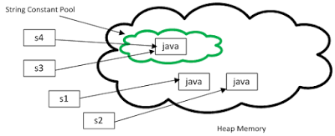](http://java67.blogspot.com/2014/01/why-string-class-has-made-immutable-or-final-java.html)

4) The intern() method is a non-static method and should be called using a String literal or String object in Java.

<http://javarevisited.blogspot.in/2015/12/when-to-use-intern-method-of-string-in-java.html>

**Q) What is String deduplication?**

Java 8 update 20 also introduced a new feature called *String deduplication*, which can reduce memory footprint caused by duplicate String without writing a single line of code, but, unfortunately, it's only available for G1 garbage collector and you cannot use it if you are using **ConcurrentMarkSweep** garbage collector.

**Q) Why String is immutable?**

Since Strings are managed in String constant pool to save the memory.

1. If it is mutable, chacing in one String literal affect the other String lieratal, which are pointing to the same.
2. **Thread safe:** if multiple threads are changing the value of string that will affect the other liferal references.
3. String literal caches hashcode to avoid repeatedly calculating the hashCode. Especially useful in the case of HashBased Algorithms.

**Q) Which API classes are useful to find the matches?**

**Pattern pattern= java.util.regex.Pattern.compile(“StringToSearch”);**

**Matcher matcher= Pattern.macher(input);**

**while( matcher.find()){**

**counter++;**

**}**

**Q) What happens when you run below code?**

String output=input.substring (input.length ());

It will return empty string instead of throwing exception.

**Q) StringBuilder which design patterns it uses?**

**StringBuilder uses Builder Design Pattern**

**New StringBuilder(“Hello”).append(“world”).append(true);**

All the (+) will replaced by final code with Stringbuilder. You can check this using below command.

**$/>javap –c <YOUR\_CLASS\_FILE>**

**Q) Difference between concat () and append () methods?**

The concat () method is on String object and append () method is on StringBuilder.

**Q) Why generally passwords are stored in the char array instead of String?**

Strings are managed inside the String constat pool they are not garbage collected. If someone got that memory dump they can easily read the password from that. To avoid this we are generally use char array to store password. Arrays are stored inside the Heap can be garbage collected if it is not reacheable.

**Q) How the HashMap put and get methods works?**

It calcuates the hashcode of the KEY which is in String format

Since Hashcode is very large number and therefore it calcuates the index using below logic

**Int index= hashCode & (length-1)**

Once the index is calculated which is within the range of hashMap size. So it will place that object in that index.

If there an element already exists in that location it will prepare a linkedList in that location and add new element there.

Get method works as mentioned below

1. First it will calcuate hashcode of the key
2. Calculates the index value of that key
3. Using this index it will look into that place for the element.
4. If the element found check both hashcodes
5. If both hashcodes are same it also checks equals method contract
6. If that returns true, then then it will return the value from that entry.

**Q) What is the Performance improvement for HashMap in java 8?**

If the more number of keys having the same hashcode (theashould above>8) linked list is replaced with the Balanced Tree. So that time complexity of the map element changed **O (n)** to **O (log n)**

**Q) Which design pattern used in Collections.synchroizedMap(map)?**

Decorator design pattern

**Q) How do you run loop in the mac terminal?**

while true

>do

>echo something

>done;

**Q) What is the advantage of using AtomicLong and AtomicInteger?**

**Generics**

**Q) What are unbounded wildcard types?**

If you want to use a generic type but you don’t know or care what the actual type parameter is, you can use a question mark instead

Ex:

**public int returnCommonElements(Set s1, Set s2){**

**Return commonElements;**

**}**

Here we are passing RAW types that are Dangerous. Instead we can pass wildcard types.

**public int returnCommonElements(Set<?> s1, Set<?> s2){**

**Return commonElements;**

**}**

For the Unbounded wildcard types we can’t add elements (except null) but we can get the elements and assign it to Object.

**Q) What are bounded types?**

List<? **extends** Animal> is bounded types

**Q) Best Practices of Object creation? Why Factory methods important to create objects instead of constructor?**

Try using static methods to return instance instead of public constructor. If you have more than two constructors available, then developer would confuse with these constructors. Static methods have name it will give correct idea which one to use.

“In cases where a class seems to require multiple constructors with the same signature, replace the constructors with static factory methods and carefully chosen names to highlight their differences.”- Effective Java

**Second Advantage of static method is follows**

Using Static methods we need not required creating new objects everytime.

Using this technique we can create immutable objects or cache these objects as they construted.

Ex: **Boolean.valueOf (true)** always return same object instead of creating new object. It follows FlyWeight Design Pattern.

It greatly improves the performance if equivalent objects are requested often.

Especially, if they are expensive to create

**What are instance-controller classes?**

The ability of static factory methods to return the same object from repeated invocations allows classes to maintain strict control over what instances exist at any time. Classes that do this are said to be instance-controlled.

Instance-controlled classes guantanee that no two equal instances exists. Which might imroves the performance. An ENUM type does this.

**Third Advantage of static methods**

Static method can return any of the child objects of that instance. This leads to a compact API. This technique called interface-based frameworks, where interface provide natural return types for static factory methods.

**Interface can’t have the static methods. How do you solve this problem?**

Static factory methods for an interface name Type (Collection) are put in a noninstantiable class Types (Collections).

NOTE: classes of this return objects are non-public which makes API conpact and developer doesn’t need to know about these classes.

Colletions provides 32 non-modifiable and synchronized collections with static methods.

The java.util.EnumSet was introduced in 1.5 has no public constructors. It returns two types of imeplementations in the backend.

* If the size of enums less or equals to 64 then return RegularEnumSet
* If the size of enums greater or equals to 65 then return JumboEnumSet

**A static method provides readability, avoids duplication of object creation and provides Compact API**

**Q) What is Service Provider Framework?**

Service provider framework is a system in which multiple Service providers implement a service.

It has three essential components

1. **Service interface:** provides implement

**Ex: Connection**

1. **Provider registration API:** which system uses to registers implementation

**Ex: DriverManager.registerDriver**

1. **Service access API:** which clients uses to access to obtain API

**Ex: DriverManager.getConnection**

1. **Service provider interface:** provides implement to create instances of their implementation.

**Ex:** Driver

Single element enum type is the best way to implement a singleton.

**Attempting to enforce noninstantiability by making a class abstract does not work.**

**// Noninstantiable utility class**

public class UtilityClass {

**// Suppress default constructor for noninstantiability**

private UtilityClass() {

throw new AssertionError();

}

... // Remainder omitted

}

The **AssertionError**isn’t strictly required, but it provides insurance in case the constructor is accidentally invoked from within the class.

**Whenever a class manages its own memory, the programmer should be alert for memory leaks**.

Ex: Stack has elements that should be nullified whenever they are popped out.

Utility classes make constructor private and throw **AssetionError** to avoid accidental instance creation.

**Q) Good practice to expose array of data from the class object?**

It is wrong for a class to have a public static final array field, or an accessor that returns such a field. Instead we can go with following two approaches

**1). Making public immutable array**

private static final String[] array=new String[5];

public static final List<String> publicArray = Collections.unmodifiableList(Arrays.asList(array));

**2). Maku public method and return copy (clone) of that array**

private static final String[] array=new String[5];

public static final String[] values(){

return array.clone();

}

When you clone object properties are referenced and not cloned.

1. OOPs concepts.

2. What is Classloader?

3. What is first class loads in classloader?

4. Difference b/w abstract & interface?

5. Why we need interfaces? p

6. Sharing objects b/w threads?

7. Design patterns(singleton and facade)?

8. What are heap dumps?

9. SQL Injection?

10. How JVM works?

11. Why strings are immutable - write a program to prove

12. What is OutOfMemory? When this happens?

13. PermGenSpace?

14. Singleton.

15. Why public static void main? What if i use private instead of public?

16. Handling Exceptions

17. Why CustomExceprions?

18. Difference b/w throw & thows?

19. when you throw custom exception in your application

20. string vs new String()

21. Facade pattern

22. Comparator

23. Hibernate configuration?

24. HQL queries

25. Hibernate advantages

26. 3 fastest tasks done JQuery compare with javascript

27. Architechture of your application

28. High level design document

29. Team lead roles.

30. Agile.

31. JSP send redirect vs forward

32. volatile keyword

33. varargs

34. Can we achieve overloading with varargs?

35. 10 + + 11 - - 23 + + 10;(o/p)

36. String reverse program.

37. SessionFacade design pattern.

38. Difference b/w app server and web server?

39. ArrayList vs LinkedLIst

40. Why JVM platform independent?

41. Static keyword

42. Java 7 features

43. Why operator overloading is not possible in Java?

44. Error vs Exception -

1. Give an example for Encapsulation in this room?

2. How to handle the Base class exception and subclass exception (the order)

3. Write a program for Fibonacci series program recursively

4. Which approach is better Recursive or Iterative and why?

5. Inheritance with examples

6. Interfaces and abstract classes with examples

7. Towers of Hanoi

8. Difference between stub and mock

9. Given a real time scenario like one developer develops widgets, other developer consumes them. Identify the actual issues coming in this?

10. Memory model in java

11. Design patterns types, and explain one behavioral design pattern

12. Program for Singleton design pattern and different scenarios in that like Serialization, Cloning

13. Enum Singleton

14. Why java doesn’t support Multiple Inheritance

15. Composition

Deloitte Interview – Round1

1. Difference between ActionErrors and ActionMessages

2. Difference between Struts and JSF (Request based MVC and Component based MVC)

3. JSP Implicit objects

4. JSP Life cycle

5. Difference between throw & throws

6. Multiple inheritence in java

7. Difference between Framework & Design Patterns

8. JSF Life cycle

9. Difference between $ & # (in jsf we use #) in expression language ( Couldn't answer this question)

1.Exception handling

2.Super class of Exception

3.How to prevent finally block from executing?

4.throw and throws difference

5.Servlet and ActionServlet difference

6.what is session tracking

7.implicit objects in jsp

8.hashmap and hashtable difference and how to iterate them

9.PreparedStatement and CallableStatement

10.String and StringBuffer difference

11.Servlet lifecycle

1.Give Project architecure

2.Roles and responsibilities in your project

3.Best Practices implemented in the project

4.How did you debug a critical issue in your projecte give example

5.What all have you used from Collections in java

6.why AWS in your application

7.What is Drools and Solr

8.What did you do when you got invalid data.

9.did you implement caching in your application.

10.How did you implement ehcache in your application.

1)difference between throw and throws

2)What are the wrapper classes

3)what is marker interface and it uses

4)can main method override and reason

5)can I write final and abstract method?

6)Jdbc Connection Steps

7)what is the difference between resultset and rowset(didn’t answer)

8)Servlet Life Cycle.